**IoT Based Smart Village**

**Team Details:**

Total team strength: 3

Total Number of modules: 4

*Team Members:*

1. Arvind Kumar (15EC106)
2. Jayanth Putta (15EC122)
3. Shantanu Vijay (15EC145)

**Aim/Objective:**

To create an IoT based Smart Village system for a fictional village named *Palampur* that relies on Aadhaar Card Number for identification and verification. This system should be such that it improves the quality of life for the inhabitants of *Palampur* in at least four different areas. This system should make life easier for all villagers, improve resource allocation, and work to overcome problems specific to rural areas.

**Introduction:**

*Palampur* is a small village located one and a half hours from the nearest town, Mangalore. Like much of rural India, it has limited access to services and resources and the quality of life is far inferior to the rest of the country. *Palampur* is home to around 150 families with an average family size of 5.5. Most of the villagers are either engaged in agriculture or travel to Mangalore for work. The village has access to electricity and the Government of India has implemented internet facilities in the village as a Smart Village Development Scheme. Under this scheme, each family is also provided with a 3G-enabled smartphone. All villagers have registered under the Aadhaar scheme. Furthermore, it has a primary health care centre with a few nurses but no permanent doctor on duty. Rather a few doctors travel between *Palampur* and nearby villages as and when required.

For the village of *Palampur*, an IoT based smart village system consists of 4 modules that are each targeted towards one aspect of life:

* Healthcare: Smart Hospital Bed
* Irrigation: Smart Irrigation System
* Transportation: Real Time Bus Info Service
* Access to Markets: Smart Community Warehouse

**Proposed Solution (Modules):**

1. **Smart Hospital Bed:**

This module involves recording and analysing critical health data of patients at the village’s Primary Health Care Centre. We attach a Pulse Rate Sensor and a Temperature sensor to the patient’s arm. Data is continuously monitored and stored temporarily. If the patient’s temperature/pulse shows irregularities or goes outside the specified thresholds, the nurses and doctors are notified. Patient’s are logged using their Aadhaar number as ID. Further medical information (such as height and weight) is entered by a nurse and used to set the necessary thresholds.

1. **Smart Irrigation System:**

We use a moisture sensor to monitor the soil’s moisture content. The values are read at regular intervals and compared with the ideal moisture levels of a particular crop. Sprinklers are automatically activated in case moisture content falls below the ideal value. Weather data is also taken into account from a freely accessible online database and necessary action is taken. For example, if rain is predicted, a farmer should not water his crops on that day, to conserve water.

1. **Real Time Bus Info Service:**

The frequency of buses between Mangalore, and Palampur is very poor. To combat this, we use the bus conductor’s phone’s GPS to track where the bus is in real time. This way, the villagers of Palampur do not have to wait long periods for a bus to arrive. They can check where the bus is currently located and arrive at the bus stop in time. An extension to this would be that the conductor can estimate how long he should wait (based on inputs from the villagers) before leaving for Mangalore again. The assumption made here is that there is only one bus route from Palampur to the town and back.

1. **Smart Community Warehouse:**

This warehouse module serves to not only improve warehousing, but also improve access to markets and simplify finances. Farmers can bring their crops to the warehouse where government officials will supervise the weighing of the crops and quality control. Once weighed and checked, the crops will be stored in the warehouse and logged in the farmer’s name based on his Aadhaar number. When companies or supply chain agents come to purchase crops from Palampur, they will deal directly with the community warehouse, hence simplifying the process. The farmer whose crops are sold will receive payment directly into his bank account. All farmers using the warehouse will pay a nominal fee for the maintenance of the storage facility proportional to the amount of profit they make from crops sold through the warehouse.

**Block Diagram:**

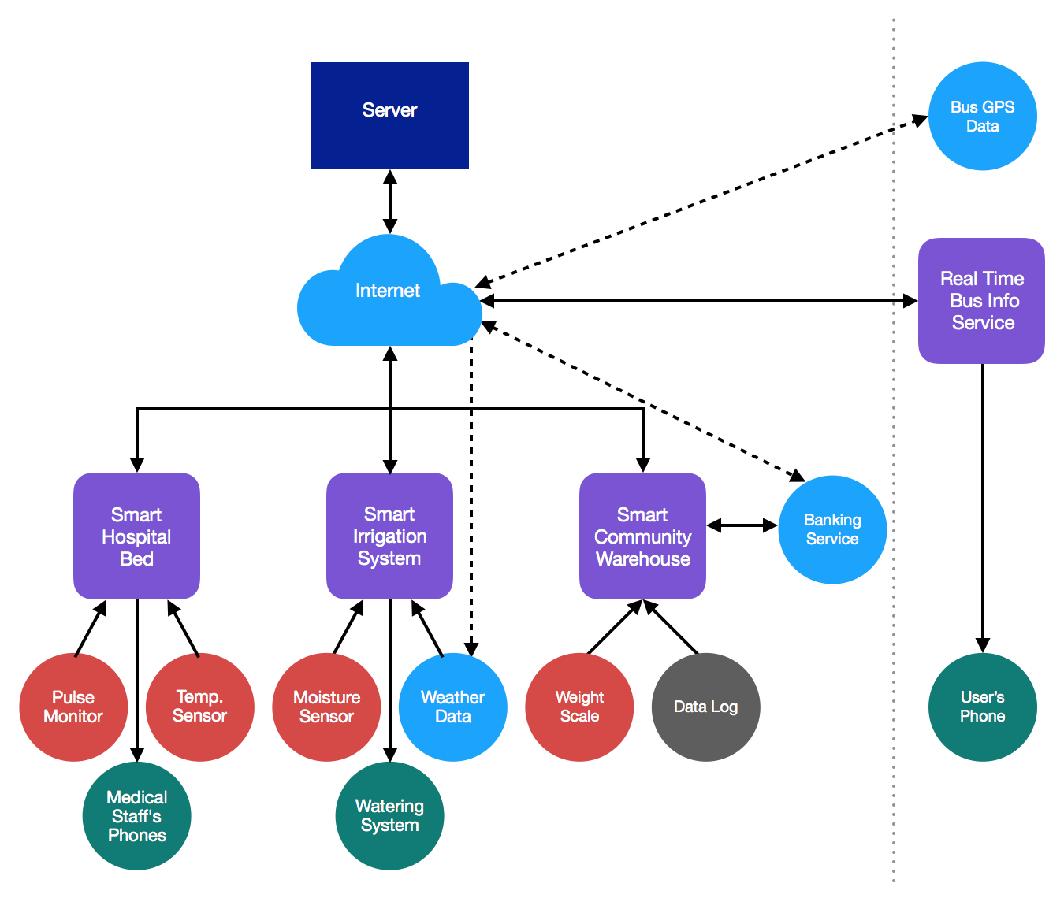

**Technologies Used:**

We anticipate the following technologies will be used:

* Raspberry Pi + Microcontroller
* Sensors: Pulse Monitor, Temperature Sensor, Moisture Sensor, Weighing Scale
* Data : GPS, Weather
* Actuators : Sprinkler Motor